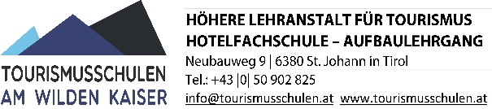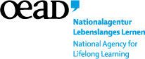 **Learning Agreement**

ERASMUS+ 2014-2020/ Vocational education

People in initial vocational education

Mobility / International work placement

***“Go Europe 2014 - 2020“***

**Host organisation:**

|  |  |
| --- | --- |
| Name of company |  |
| Address |  |
| Telephone / Fax |  |
| Email |  |
| Website |  |
| Contact person |  |
| Email |  |

Duration of the work placement: from __________ to ___________

By signing this agreement we agree to cooperate within the framework of the programme Erasmus+ (vocational education - international work placement). We declare to foster the international work placements of the participants of the Higher Vocational School for Tourism and Catering (Tourismusschulen Am Wilden Kaiser).

* We offer practical training to participants and provide board and accommodation free of charge.
* We undertake to support the participants in the best possible way to carry out their tasks and to keep in contact with the sending organisation during the work placement.
* We will introduce the participants to their areas of work, supervise and evaluate them.
* We will provide the information required to facilitate the necessary evaluation and final reports.
* We agree to pay the remuneration as agreed and to issue a work certificate.

Further rights and duties of the host organisation and the participants are indicated in the contract of employment.

Signature of contact person (Host organisation): ……………………………

|  |  |  |
| --- | --- | --- |
| **Name and position**  **(in capital letters)** | **Place and date** | **Stamp** |
|  |  |  |